Alexandria University
Faculty of Engineering
Computer Engineering and Systems dept.
4th year
2004-2005
Computer Communications and Networks

TCP/UDP Communication Project

Submitted by:

- Ahmed Ragab El-Habashy Ragab (5 )
- Ahmed Samy Hamed Shaalan (6 )
- Shahira Kamal El-Din Abou Samra (40)
- Ossama Yehia Mohamed ( )
- Mohamed Abd-ElAziz Khamis (56)

Supervisors:

Prof. Dr. M. Nazieh El-Derieni Dr. Sahar M. Ghanem
Eng. Wael M. Shaaban
Problem Statement:
Implement a CommServerBox and a CommClientBox.

The command line for running a CommServerBox on machine X is
X>CommServerBox tcp-port udp-port
Where the TCP and UDP servers binding addresses are (X, tcp-port) and (X, udp-port) respectively.

A CommServerBox has to be running before starting a CommClientBox. The command line for running a CommClientBox on machine Y is
Y>CommClientBox X tcp-port udp-port where X is a machine name (e.g. hours.alex.edu.eg) or IP (e.g. 128.15.115.9), and tcp-port and udp-port are the TCP and UDP servers’ ports.

After finishing the implementation, any CommServerBox (implemented by a group) should be able to communicate with any CommClientBox (implemented by another group).

Note that, being a server could fail due to the use of NAT, but it is allowed to use some of the PCs that are connected to the Internet (through a LAN), or you can hookup your laptops to any of the available sockets for testing.

A CommServerBox and a CommClientBox are communicating through 3 channels as follows:
1) Channel_1: a TCP control channel, where a CommClientBox is the TCP client. This channel is established at the beginning of the communication and terminated when the communication is done.
2) Channel_2: a TCP test channel, where a CommClientBox is the TCP server. The channel is used temporarily to test the CommClientBox’ machine ability of being a
TCP channel
3) Channel_3: a UDP channel, where a CommClientBox acts as an UDP echo client.

Communication between a CommServerBox and a CommClientBox should proceed as follows:
CommClientBox | CommServerBox
Channel_1 | Channel_1
- Send [READY|tcp-port2], where tcp-port2 is Channel_2 server port.  - Receive [SERVER-TIMESTAMP|ts1]  - Send [CLIENT-TIMESTAMP|ts1|ts2], where ts2 is the timestamp of sending such message  - Channel_2 communication  - Receive [You can …]  - Send [I can …]  - Channel_3 communication  - Send [UDP-ECHO|status], where status can be FAILED, TIMEOUT|N, or DONE|N; and N is the number of successfully echoed messages.  - IF (N>0) Receive [UDP-ECHO|N|M]  - Receive [TEST-WELL-DONE]  - Close Channel_1 | - Receive [READY|tcp-port2]  - Send [SERVER-TIMESTAMP|ts1], where ts1 is the timestamp of sending such message  - Receive [CLIENT-TIMESTAMP|ts1|ts2]  - Channel_2 communication  - Send [You can be a server] or [You can’t be a server]  - Receive [I can …]  - Channel_3 communication  - Receive [UDP-ECHO|status]  - IF (N>0) Send [UDP-ECHO|N|M], where M is the number of successfully echoed messages at the UDP echo server.  - Send [TEST-WELL-DONE]  - Close Channel_1
Channel_2 | Channel_2
- Receive [CLIENT-ECHO-REQUEST |message]  - Send [SERVER-ECHO-REPLY|message]  - Receive [OK] or [NOT-OK]  - Close Channel_2 | - Send [CLIENT-ECHO-REQUEST[message]  - Receive [SERVER-ECHO-REPLY |message]  - Send [OK] or [NOT-OK]  - Close Channel_2
Channel_3 | Channel_3
Do 10 times  - Send [ECHO-REQUEST|message]  - Receive [ECHO-REPLY|message]  if not received retransmit 3 times, if not  received after 3rd retransmission quit loop  after loop is done, N is the number of  received messages:  If (N==0) status =FAILED  If(N<10) status = TIMEOUT  If (N==10) status =D ONE | - Receive [ECHO-REQUEST|message]  - Send [ECHO-REPLY|message]

Pseudo code TCP client
• Create socket, connectSocket
• Do an active connect specifying the IP address and port number of server
• Read and Write Data Into connectSocket to Communicate with server
• Close connectSocket

Pseudo code TCP server
• Create socket (serverSocket)
• Bind socket to a specific port where clients can contact you
• Register with the kernel your willingness to listen that on socket for client to contact you
• Loop
Accept new connection (connectSocket)
Read and Write Data into connectSocket to Communicate with client
Close connectSocket
End Loop
• Close serverSocket

Client/server socket interaction: TCP
(Java)
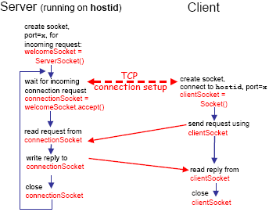

Pseudo code UDP client
• Create socket
• Loop
(Send Message to Well-known port of server)+
(Receive Message from Server)
• Close Socket

Pseudo code UDP server
• Create socket
• Bind socket to a specific port where clients can contact you
• Loop
(Receive UDP Message from client x)+
(Send UDP Reply to client x)*
• Close Socket

Client/server socket interaction: UDP
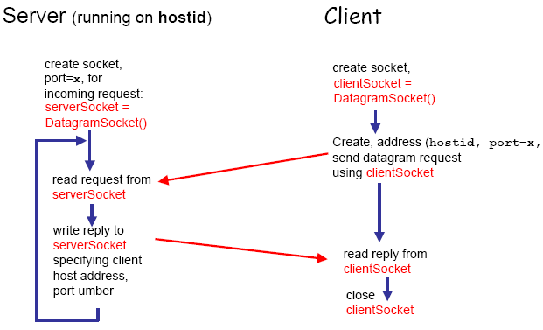

CommClientBox
Channel_1
Connect to CommServerBox
Send [CLIENT-TIMESTAMP|ts1|ts2], where ts2 is the timestamp of sending such message

Receive [SERVER-TIMESTAMP|ts1]

Send [READY|tcp-port2], where tcp-port2 is Channel_2 server port
Channel_2 communication

Receive [You can …]

Send [I can …]
Channel_3 communication

If the header of the received message = SERVER-TIMESTAMP
If the header of the received message = You can . . .
Yes
No
Close Program
Yes
No

CommClientBox
Channel_1 (cont.):
Receive [UDP-ECHO|N|M]
Receive [TEST-WELL-DONE]
N>0
Close Channel_1
Send [UDP-ECHO |status], where status can be FAILED, TIMEOUT|N, or DONE|N; and N is the number of successfully echoed messages.

Channel_3 communication

Yes
Close Program
If the header of the received message =
UDP-ECHO
If the header of the received message =
TEST-WELL-DONE
No
No
No
Yes
Yes
CommServerBox
Channel_1
Receive [READY|tcp-port2]

Send [SERVER-TIMESTAMP|ts1], where ts1 is the timestamp of sending such message

Channel_2 communication

Receive [I can …]

Send [You can be a server] or [You can’t be a server]
Receive [CLIENT-TIMESTAMP|ts1|ts2]

Channel_3 communication

If the header of the received message = READY
Yes
If the header of the received message = I can …
If the header of the received message = CLIENT-TIMESTAMP
Close Program
No
No
No
Yes
Yes

CommServerBox
Channel_1 (cont.)
Channel_3 communication

Receive [UDP-ECHO |status]
N>0
Send [UDP-ECHO|N|M], where M is the number of successfully echoed messages at the UDP echo server.
.

Send [TEST-WELL-DONE]
Close Channel_1
If the header of the received message = UDP-ECHO
Yes
No
Yes
No
Close Program

CommClientBox
Channel_2
Receive [CLIENT-ECHO-REQUEST |message]

Send [SERVER-ECHO REPLY|message]
Receive [OK] or [NOT-OK]

Close Channel_2
If the header of the received message = CLIENT-ECHO-REQUEST
If the header of the received message =
OK or NOT-OK
Close Program
Yes
Yes
No
No

CommServerBox
Channel_2
Send [CLIENT-ECHO-REQUEST |message]

Receive [SERVER-ECHO-REPLY|message]
Send [OK] or [NOT-OK]

Close Channel_2
Connect to CommClientBox
(As a server)
If the header of the received message =
SERVER-ECHO- REPLY
Close Program
Yes
No

CommClientBox
Channel_3
Send [ECHO-REQUEST |message]

Receive [ECHO-REPLY |message]

Do 10 times
Next
Retransmit 3 times
If the header of the received message =
ECHO- REPLY
After the 3rd retransmission:
If the header of the received message =
ECHO- REPLY

Quit Loop
Yes
Yes
No
No
Note:
After the loop is done, N is the number of received messages:
If (N= = 0) status = FAILED
If (N< 10) status = TIMEOUT
If (N = = 10) status = DONE

CommServerBox
Channel_3
Receive [ECHO-REQUEST |message]

Send [ECHO-REPLY |message]

If the header of the received message =
ECHO- REQUEST
Close Program
Yes
No

